ER100
FAST CURING PRE-BLENDED POLYMER MODIFIED CEMENT BASED RENDER

TECHNICAL DATA SHEET

ER 100 is a multipurpose, acrylic render that boasts superior strength.

ER 100 unique formulation allows it to be applied up to 10mm with no sagging or cracking. ER 100 can be used by using a hawk and trowel over a variety of surfaces including AAC blocks, AFS, brickwork, fibre cement sheeting, concrete and polystyrene board (contact your nearest Novatex office for correct application).
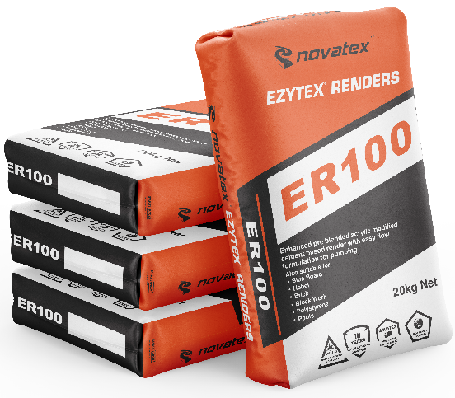

- Acrylic modified.
- Superior setting strength
- Fast curing
- Build up to 10mm in single application.
- Unique PFR Technology

Superior formulation, ideal product for commercial applications e.g. shopping centres, high rise and housing developments.

Suitable for traditional style rendering methods.

Ideal for bonding a large range of substrates including AAC blocks, AFS, brickwork, fibre cement sheeting, concrete and polystyrene board.

Low VOC content- meets Green Building Council of Australia Green Star IEQ-13 requirements.

ER100: FAST CURING PRE-BLENDED POLYMER MODIFIED CEMENT BASED RENDER

Characteristics
ER100 is a multipurpose, acrylic render that boasts superior trowel ability, and its unique formulation allows it to be applied up to 12mm with no sagging or cracking. ER100 can be applied using traditional hawk and trowel methods over brick work, AAC blocks, blue board (fibre cement sheet) concrete and polystyrene board (contact your nearest Novatex office for correct application).

Preparation
Ensure new concrete is allowed to cure for a minimum of 5 days. Ensure all surfaces are sound, dry and free from oil, dust, grease, wax, curing compounds, release agents and any other contaminating materials. It is recommended that all dry and porous surfaces should be primed first using Nova Mix Additive with water mixed 1:1. Warning, do not over seal, only apply one coat. Where excessive suction is a problem add approximately 200ml of Nova Mix Additive per bag to first coat.

Mixing
Depending on weather conditions and application a slight variation in the amount of water may be required. The mixing ratio of ER100 is 20kg of powder to 4-4.5 litres of water. Pour 4 to 4.5 litres of clean water into a drum and then gradually add the ER100 while mixing continuously until smooth lump free mix is obtained. Always add powder to liquid. Allow the mix to stand for 2 min. Re stir and the ER100 is ready to use.

Application
Once the substrate has been correctly prepared in accordance with the above instructions. Trowel on ER100 onto surface and level off using a plastic float. Apply using traditional rendering methods. ER100 can be applied between 3-12mm per coat. The final coat must be painted with Bondi Bling or with an acrylic sealer and two coats of good quality paint. Allow at least 5 days for curing (depending on weather conditions) before painting. When applying over polystyrene or blue board mix 500ml of Nova Mix Additive to 4L of water (water ratio may vary for different applications) then use gauging water to mix in with powder.

Drying Time
ER100 is touch dry in 2-4hrs @ 23°C. Second coat may be applied after 6-8hrs, and surface will reach full cure after 7 days. Before application of a decorative finish (i.e. paint) allow ER100 to cure for a minimum of 1 day per 2mm thickness of the render. Cold, damp or humid conditions may lengthen the drying time.

Coverage
2-4m² per 20kg bag depending on surface and application thickness.

Cleaning
Keep out of sewers and storm water. Sweep up spills. Novatex render can be cleaned off equipment with water, provided ER100 has not dried.

Shelf Life
12 months when stored in a dry place, in original unopened packaging.

The information supplied is to the best of our knowledge true and accurate. The actual application of the product is beyond the manufacturer’s control. Any failure or damage caused by the incorrect usage of the product is not the responsibility of the manufacturer. The manufacturer insists that all workmanship must be carried out in accordance with the manufacturer’s specification. To the full extent permitted by law, Novatex Products Pty Ltd liability is limited to its discretion, to replacement of good or the supply of equivalent goods.

ER100: FAST CURING PRE-BLENDED POLYMER MODIFIED CEMENT BASED RENDER

Precautions
ER100 is not suitable for using over floors. If applying over painted surfaces prime area using Optimus
Primer (contact your nearest Novatex office for correct application). Do not apply in temperatures below 5°C or above 35°C or application in extreme conditions such as high wind, direct sunlight, rain and water runoff.

Health and Safety
The powder can be irritable; Paper dust protection masks must be worn while product is being mixed. The wet compound is alkaline and prolonged skin contact should be avoided.

Disclaimer
Please note: Recommendations and advice regarding the use of this product are to be taken as a guide only. Novatex shall not be liable for any inaccuracy in the information given or for any loss, injury or damage whatsoever resulting from its use. To the full extent permitted by law, Novatex Products liability is limited to its discretion, to replacement of goods or the supply of equivalent goods. For applications/ situations not mentioned on this packaging, please contact your nearest Novatex office.

