Hi Build
UNIQUE LIGHT WEIGHT HI BUILD RENDER
TECHNICAL DATA SHEET

Hi Build Lo Weight is a light weight, acrylic modified cement render that boasts ability to build up 40mm thickness with superior trowelability.

Hi Build Lo Weight has been designed to build up and level undulating surfaces. Suitable to be applied over brick work, AAC blocks, blue board (fibre cement sheet) concrete, polystyrene surfaces and specified light weight building substrates.

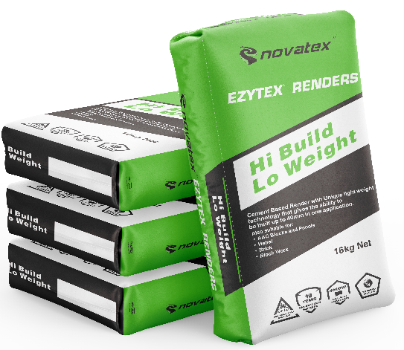
- Unique light weight technology.
- Ability to be built up to 40mm.
- Superior Adhesion.
- Ideal for light weight building substrates.

Superior coverage, ideal product for commercial applications e.g. shopping centres, high rise and housing developments.

Suitable for rendering over a large range of substrates.

Superior Trowelability able to be levelled off.

Low VOC content- meets Green Building Council of Australia Green Star IEQ-13 requirements.

Hi Build: UNIQUE LIGHT WEIGHT HI BUILD RENDER

Characteristics
Hi Build Lo Weight is a light weight, acrylic modified cement render that boasts superior trowel ability. With its unique formulation it can be applied up to 40mm with no sagging or cracking. Hi Build Lo Weight has been designed to build up and level undulating surfaces and is suitable to be applied over correctly prepared brick work, AAC blocks, blue board (Fibre cement sheet) concrete, polystyrene surfaces and specified light weight building substrates.

Preparation
All surfaces must be clean and free from dirt, dust, oil, grease and porous surfaces be primed first using Nova Mix additive with water mixed 1:1. For non-porous surfaces prime area using Optimus primer before rendering.

Mixing
Depending on weather conditions and application a slight variation in the amount of water may be required. Always add powder to liquid, pour 4 litres of water into a clean bucket and slowly add Hi Build Lo Weight powder while stirring. Add entire content of bag and adjust with water to achieve the desired consistency. Allow to stand for 2 minutes before application.

Application
Hi Build Lo Weight application should only be carried out by a skilled and experienced applicator. Hi Build Lo Weight should not be applied in a single coat greater than 40mm. Hi Build Lo Weight can be sprayed on with a suitable machine or applied manually using traditional hawk and trowel methods.

Allow Hi Build Lo Weight to firm up sufficiently prior to ruling – off to form a flat surface. Lightly float to achieve a smooth surface. Hi Build Lo Weight is not designed as a finishing render, but as a base coat. Render should be sheltered from rain and moisture for 24hrs after completion dependent on climatic conditions. Once Hi Build Lo Weight is fully cured the application of Nova Coat Texture coatings or Ezytex powder textures may commence. Hi Build Lo Weight should not be left uncoated for an extended period. For applications not mentioned contact Novatex for information.

Drying Time
Hi Build Lo Weight dries in approximately 24 hours under normal drying conditions. (dry times may vary due to temperature, humidity and residual moisture in the substrate). PLEASE NOTE THAT 20-40MM THICK COAT NEEDS EXTRA TIME TO CURE AND DRY BEFORE OVERCOATING CAN COMMENCE. Once initial dry set has occurred, rewet 1 to 2 times a day with clean water for 2 days. This is especially important during hot/and or windy weather under normal conditions.

Coverage
A 16kg bag of Hi Build Lo Weight will cover approximately 2 square metres @ 10mm Build.

Cleaning
Keep out of sewers and storm water. Sweep up spills. Novatex render can be cleaned off equipment with water, provided the compound has not dried.

The information supplied is to the best of our knowledge true and accurate. The actual application of the product is beyond the manufacturer’s control. Any failure or damage caused by the incorrect usage of the product is not the responsibility of the manufacturer. The manufacturer insists that all workmanship must be carried out in accordance with the manufacturer’s specification. To the full extent permitted by law, Novatex Products Pty Ltd liability is limited to its discretion, to replacement of good or the supply of equivalent goods.
Shelf Life
12 months when stored in a dry place, in original unopened packaging.

Precautions
Hi build Lo Weight is not suitable for using over floors. If applying over painted surfaces prime area using Optimus Primer (contact your nearest Novatex Office for correct applications) Do not apply in temperatures below 5°C or above 35°C or application in extreme conditions such as high wind, direct sunlight, rain and water runoff.

Health and Safety
The powder can be irritable; paper dust protection masks must be worn while product is being mixed. The wet compound is alkaline and prolonged skin contact should be avoided.

Disclaimer
Please Note: Recommendations and advice regarding the use of this product are to be taken as a guide only. Novatex Products shall not be liable for any inaccuracy in the information given or for any loss, injury or damage whatsoever resulting from its use. To the full extent permitted by law, Novatex Products liability is limited to its discretion, to replacement of goods or the supply of equivalent goods. For applications/situations not mentioned on this packaging, please contact your nearest Novatex office.

Contact Us
For further technical information, please contact Novatex Products on 02 9616 6500

