Nova grout Epoxy
CHEMICAL RESISTANT

TECHNICAL DATA SHEET

Nova Grout Epoxy is a three-part, commercial grade water clean-up epoxy system. Its uniquely designed with the colour being in the liquid component.

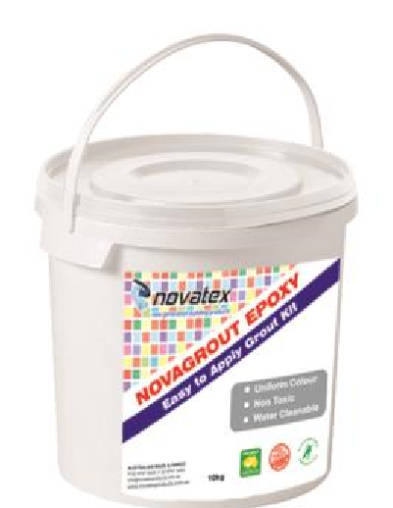
- For internal and external wall and floor applications.
- Tough, high mechanical strength.
- Chemical resistant
- Non shrink.
- For use in joints from 1.2mm to 6mm.
- Specially designed formula makes Nova Grout easy to clean off tiles with water.

Specially designed properties give increased stain and chemical resistance values.

Specially designed for commercial kitchens, Hospitals, food processing plants, public toilets, residential areas, and where high chemical resistance is required.

Low VOC content which easily meets Green Building Council of Australian Star IEQ-13 requirements.

Nova grout Epoxy: CHEMICAL RESISTANT

Designed for Grouting
Suitable for wall and floor applications and internal and external use.
Ideal for grouting a large range of tile types including ceramic, fully vitrified, porcelain, marble, natural stone, terrazzo, glass, and mosaics. (contact your nearest Novatex Office for correct application). Ideal for joints 1.2mm to 6mm in width.

Substrates
Concrete, renders, screeds, Nova proof waterproofing membrane, blockwork, gyprock, plasterboard, fibre cement, particle board and Swimming pools (Refer to your nearest Novatex office for correct application).

Preparation
Ensure that tile adhesive has had sufficient time to cure before grouting commences.
Remove any adhesive that may have come out from joints, remove spacers and any dust or dirt or other contaminants from joints before grouting. Do not apply Grout in expansion joints.

Mixing
Mix Part A (Colour) with Part B (Hardner) in clean container, mix well, then slowly add in Nova Grout Epoxy powder into liquid while mixing continuously until a smooth lump free mix is obtained. Always add powder to liquid. Allow to stand for 2 mins and then restir. Grout is now ready to use. Nova Grout Epoxy should not be used in areas where movement will occur.

Application
Use a grout applicator to apply the grout into the joints. Apply the grout using a diagonal motion, ensuring that the grout goes into the entire depth of the joint. Grout approximately 1m² at a time then wipe off. Make sure that the sponge is rinsed properly, and no excess water remains on the sponge while wiping grout. For best results use warm water when cleaning. Make sure that the cleaning water is changed regularly. Allow grout to cure for 24hrs. Do not leave any residue on the tiles.

Pot Life
1 hour once mixed at 20°C.

Coverage
Coverage of Nova Grout Epoxy will vary depending on tile and grout joint size.

Packaging
Nova Grout Epoxy is available in a 10 kg Kit which includes 1.6L Part A (Colour) 0.8l Part B Hardener and 2 x 4kg Powder.

Shelf Life
When kept in a cool, dry environment unopened, and stored above ground level, will have a shelf life of approximately 12 months.

Clean Up.
Tools and other equipment can be cleaned up using water while the grout is still wet.

The information supplied is to the best of our knowledge true and accurate. The actual application of the product is beyond the manufacturer’s control. Any failure or damage caused by the incorrect usage of the product is not the responsibility of the manufacturer. The manufacturer insists that all workmanship must be carried out in accordance with the manufacturer’s specification. To the full extent permitted by law, Novatex Products Pty Ltd liability is limited to its discretion, to replacement of good or the supply of equivalent goods.
Nova grout Epoxy: CHEMICAL RESISTANT
Colour Available | Grey, Antique White, Beige, Charcoal
Mixing Ratio | x 4kg powder/1.6 Ltrs Part A & 0.8 Ltrs Part B
Wet Density | 1.7 Kg/L
Application Properties at 23°C and 50% RH
Drying time | hours
Ready for use | hours
Pot life | 1hr depending on conditions
Suitable for Under floor heating | Yes
Mechanical Properties | (ISO 13007.3)
Abrasion Resistance | < 250mm3
Compressive Strength | >60MPa
Flexural Strength | >30MPa
Shrinkage | < 1.5mm
Water Absorption after 240m | < 0.1g
Classification | RG
Precautions
Do Not apply Nova Grout in temperatures below 5°C and above 35°C. Nova Grout can be used in areas of water immersion like swimming pools, spas, etc. Staining may result if Nova Grout Epoxy is used to grout Natural Stones, unglazed or porous tiles. It is essential that Nova Grout Epoxy has been cleaned of tiles thoroughly before setting as once cured it will be hard to remove. For a full MSDS on this product please contact Novatex Products Pty Ltd.

Nova Grout being cement based is alkaline in nature, and therefore may cause dermatitis. It is recommended that applicators wear PVC gloves or similar and safety goggles.

Technical Data

Contact Us For further technical information please contact Novatex Products on 02 9616 6500.

