NOVAPRIME
SPECIALLY FORMULATED ACRYLIC BASED PRIMER

TECHNICAL DATA SHEET

NovaPrime is an acrylic based wall and floor primer for use on all porous surfaces before applying Novatex Tile Adhesives, Waterproofing Membranes and Renders.

NovaPrime will improve workability and open time of Novatex Adhesives, Waterproofing and Renders.
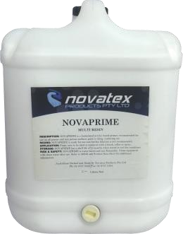

- Non tacky under feet once applied.
- Dries Clear

Low VOC content which easily meets Green Building Council of Australia Green Star IEQ13 requirements.

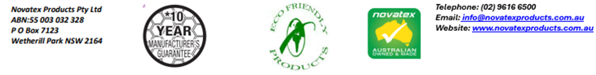
NOVAPRIME: SPECIALLY FORMULATED ACRYLIC BASED PRIMER

Application
Pour primer onto floor surface and spread using a brush, roller ensuring the entire area is primed.
Allow primer to dry for approximately 5 minutes before commencing tiling, rendering or waterproofing.

Clean up.
Tools and other equipment can be cleaned up using water while the primer is still wet.

Coverage
Coverage of NovaPrime may vary depending on the porosity of the substrate. As a guide NovaPrime will cover 7m² per litre.

Packaging
NovaPrime is available in 1 litre and 5 litre jerry cans and 20 litre cubes.

Shelf Life
A pail of NovaPrime, when kept in a cool, dry environment, and stored above ground level, will have a shelf life of 12 months.

Manual Handling
Manual handling of this product without due care and attention may result in personal injury.

Precautions
NovaPrime is a non-Hazardous product. It is water based and non-flammable. In case of eye contamination, rinse thoroughly with clean water. If irritation persists, seek medical advice. Do not apply where damp or Hydrostatic pressure is evident. For applications/situations not mentioned contact Novatex office. The manufacturer is not responsible for any loss or damage arising from incorrect use. The use of this product is beyond the control of the manufacturer and liability is restricted to the replacement of material proven faulty.

Health and Safety
NovaPrime is a non-hazardous product. Ensure adequate ventilation when using. If product splashes into eyes rinse thoroughly for at least 15 minutes with clean water. If NovaPrime comes in contact with the skin, wash well to remove.

Handy Tips
Do Not apply NovaPrime in temperatures below 5°C and above 35°C. For application not mentioned in this data sheet please contact Novatex Products Pty Ltd. For a full MSDS on this product please contact Novatex Products Pty Ltd. NovaPrime is classed a non-hazardous product.

Technical Data

Appearance | White Liquid
Dry time | 20mins @ 20⁰C
Contact Us
For further technical information, please contact Novatex Products on 02 9616 6500.

The information supplied is to the best of our knowledge true and accurate. The actual application of the product is beyond the manufacturer’s control. Any failure or damage caused by the incorrect usage of the product is not the responsibility of the manufacturer. The manufacturer insists that all workmanship must be carried out in accordance with the manufacturer’s specification. To the full extent permitted by law, Novatex Products Pty Ltd liability is limited to its discretion, to replacement of good or the supply of equivalent goods.

