NOVARAPID
SUPER GRADE POLYMER MODIFIED TILE ADHESIVE

TECHNICAL DATA SHEET

Nova Rapid is a Calcium Chloride based liquid designed to make any cement-based product set and develop initial strength fast.
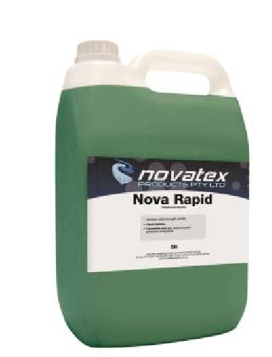

Nova Rapid is specially designed for the use with Novatex tile adhesives, grouts, and renders.

Nova Rapid is recommended for use where fast setting results are required.

Can be used with sand and cement screeds to speed curing times.

Ideal product to use when same day tiling and grouting is required.

For a full MSDS on this product please contact Novatex Products Pty Ltd.

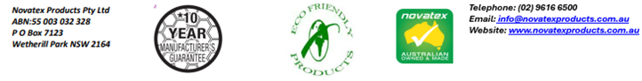
NOVARAPID: SUPER GRADE POLYMER MODIFIED TILE ADHESIVE
Set Time |  | Amount of Nova Rapid to use
 | Renders, Sanded Grouts, Sand and Cement Screeds | Supa nova, Nova Mastic, Nova Ezy, Smooth Grouts | Novaflex, Novaflex Plus, Uninova
3 hours | 100ml | 150ml | 200ml
2 hours | 200ml | 300ml | 400ml
1 hour | 300ml | 450ml | 600ml
½ hour | 400ml | 600ml | 1000ml
Preparation
Nova Rapid is a Calcium Chloride based liquid designed to make any cement-based product set and develop initial strength fast.
Nova Rapid is specially designed for the use with Novatex tile adhesives, grouts, and renders Nova Rapid is recommended for use where fast setting results are required.
Ensure surfaces are sound, dry, and free from movement, oil, grease, wax, dust and any curing and release agents.

Application
Nova Rapid must be mixed into the gauging water of the adhesive, render or screed. The amount of Nova Rapid mixed into the gauging water will determine the set time. Set time may vary if temperature drops under 18°C during curing.

The quantity is calculated per 20kg bag of mixed product.

For any application not mentioned in this data sheet please contact Novatex Products Pty Ltd.

Packaging/Shelf life
Nova Rapid is available in 5lt and 1lt pails.
A pail of Nova Rapid, when kept in a cool, dry environment, and stored above ground level, will have a shelf life of approximately 12 months.

Precaution
Do not apply Nova Rapid in temperatures above 38°C and below 5°C. Do not use in conjunction with metallic hardeners or reinforced concrete.

Clean up.
Tools and other equipment can be cleaned up using water while the product is still wet.

The information supplied is to the best of our knowledge true and accurate. The actual application of the product is beyond the manufacturer’s control. Any failure or damage caused by the incorrect usage of the product is not the responsibility of the manufacturer. The manufacturer insists that all workmanship must be carried out in accordance with the manufacturer’s specification. To the full extent permitted by law, Novatex Products Pty Ltd liability is limited to its discretion, to replacement of good or the supply of equivalent goods.

