NOVABOND ADDITIVE
SPECIALLY DESIGNED ACRYLIC POLYMER ADDITIVE

TECHNICAL DATA SHEET

Nova bond Additive is an acrylic polymer additive specifically formulated to be mixed with Novatex cement-based renders and adhesives to increase strength and flexibility.

Nova bond Additive can be mixed with Novatex Grouts when grouting over substrates prone to movement e.g. timber floors, lift foyers, train stations.
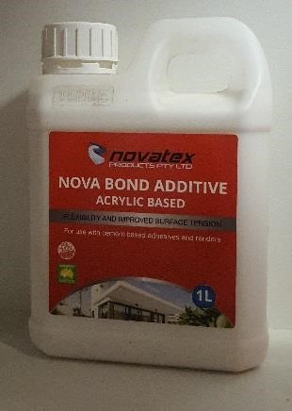

Nova bond Additive can be mixed with sand and cement for increased strength and flexibility and mixed with neat cement as a slurry coat.

High polymer content giving it the capability to increase adhesion.

Unique formula allowing it to be mixed with any Novatex cement-based product.

When mixed with Nova grout allows grout to be used as adhesive.

Low VOC content which easily meets Green Building Council of Australia Green Star IEQ-13 requirements.

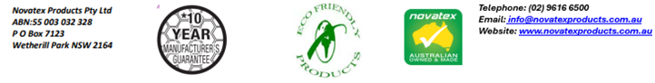
NOVABOND ADDITIVE: SPECIALLY DESIGNED ACRYLIC POLYMER ADDITIVE

Mixing
When mixing with grout mix 1 part additive to 3 parts waters. When mixing with Novatex adhesives for swimming pool application mix 1 part additive to 2 parts waters then use this as gauging liquid for adhesive. When using as a slurry coat mix 1-part neat cement with 1-part Nova bond Additive. When mixing with Novatex Renders mix 1 part additive to 3 parts water the use this as gauging liquid for renders.

Clean up.
Tools and other equipment can be cleaned up using water while the additive is still wet.

Coverage
Coverage of Nova bond Additive will vary depending on application.

Packaging
Nova bond Additive is available in 1 litre and 5 litre jerry cans and 20 litre cubes.

Shelf life
A pail of Nova bond Additive, when kept in a cool, dry environment, and stored above ground level, will have a shelf life of approximately 12 months.

Precautions
Nova bond Additive is a non-Hazardous product. It is water based and non-flammable. In case of eye contamination, rinse thoroughly with clean water. If irritation persists, seek medical advice. Do not apply where damp or Hydrostatic pressure is evident. For applications/situations not mentioned contact Novatex office. The manufacturer is not responsible for any loss or damage arising from incorrect use. The use of this product is beyond the control of the manufacturer and liability is restricted to the replacement of material proven faulty.

Health and Safety
Nova bond Additive is a non-hazardous product. Ensure adequate ventilation when using. If product splashes into eyes rinse thoroughly for at least 15 minutes with clean water. If Nova bond Additive comes in contact with the skin, wash well to remove.

Manual Handling
Manual handling of this product without due care and attention, may result in personal injury.

Handy Tips
Do Not use Nova bond Additive in temperatures above 38°C and below 5°C.
For application not mentioned in this data sheet please contact Novatex Products Pty Ltd. For a full MSDS on this product please contact Novatex Products Pty Ltd.

Contact Us
For further technical information, please contact Novatex Products on 02 9616 6500.

Technical Data
Appearance | White Liquid

The information supplied is to the best of our knowledge true and accurate. The actual application of the product is beyond the manufacturer’s control. Any failure or damage caused by the incorrect usage of the product is not the responsibility of the manufacturer. The manufacturer insists that all workmanship must be carried out in accordance with the manufacturer’s specification. To the full extent permitted by law, Novatex Products Pty Ltd liability is limited to its discretion, to replacement of good or the supply of equivalent goods.

