Optimus Primer
PRIMER FOR ENHANCING ADHESIONS

TECHNICAL DATA SHEET

Optimus Non-Porous Primer is a unique solvent free primer specifically designed with adhesion enhancing properties for use onto metallic, smooth, dense, and non-porous surfaces. Optimus Non-Porous Primer is a safe alternative to hazardous solvent based primers and etching products, to enable the adhesion of Novatex renders, adhesives, and waterproofing membranes over non-absorbent surfaces.

- Solvent free, non-flammable and free of hazardous odours
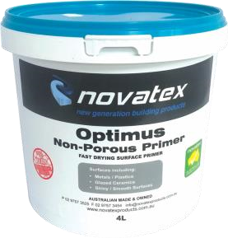
- Suitable for internal and external priming applications
- Fast drying
- Excellent water resistance
- Easy alternative to grinding and etching surfaces.
- Ideal for Dincel walls

Suitable for priming over galvanized iron, zincalume, stainless steel, copper, brass, most metals, glazed tiles, dense concrete, Dincel Wall, PVC, rigid plastics, and general nonporous, shiny surfaces.

Low VOC content which easily meets Green Building Council of Australia Green StarIEQ-13 requirements.

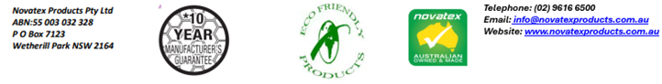
Optimus Primer: PRIMER FOR ENHANCING ADHESIONS

Designed for Priming
Suitable for wall and floor applications internal and external use.
Ideal for priming over a large range of non-porous surfaces including ceramic, fully vitrified, porcelain tiles and glass mosaic, Dincel wall systems, metals, vinyl flooring and most plastic surface. Ideal for overwater-based paints and waterproofing membranes.

Preparation
Surfaces must be prepared thoroughly before commencing. Surfaces are to be sound, stable, dry and clean, free of loose foreign matter including any surface residues or existing coatings. Buildings are to be constructed to relevant building standards and manufacturers recommendations are to be followed for all building materials used.
When laying over existing tiles, clean them thoroughly and remove all loose or drummy, and re-adhere using UniNova, then Optimus Primer.

Mixing
Optimus Primer is ready for use. Do not dilute.

Application
Stir product well before using. Apply with a long bristle brush or roller. Before applying on metals, plastics, or glazed tiles, ensure all solvent or film residues are removed.

Coverage
General coverage is 1 litre/10m² on general smooth even surfaces.

Packaging
Optimus Primer is available in a 4-litre pail.

Shelf Life
Optimus Primer when kept in a cool, dry environment, and stored above ground level, will have a shelf life of 12 months. Do not store in direct sunlight.

Clean up.
Tools and other equipment must be cleaned up using water while the primer is still wet. Once product dried it needs to be removed mechanically.

Precautions
Not to be used over absorbent porous surfaces. Not to be left exposed as finished membrane or sealer. Not to be used as a membrane. Do not apply solvent coatings over dried primer surface. Primer must dry before over coating with finishes. Not to be applied when surface temperature is below 10°C or above 35°C. Optimus PRIMER is part of Novatex Products Tiling and Waterproofing System.

The information supplied is to the best of our knowledge true and accurate. The actual application of the product is beyond the manufacturer’s control. Any failure or damage caused by the incorrect usage of the product is not the responsibility of the manufacturer. The manufacturer insists that all workmanship must be carried out in accordance with the manufacturer’s specification. To the full extent permitted by law, Novatex Products Pty Ltd liability is limited to its discretion, to replacement of good or the supply of equivalent goods.
Optimus Primer: PRIMER FOR ENHANCING ADHESIONS

Appearance | Blue paste
Dry time | – 40 minutes after application
Health and Safety
Optimus Primer is a non-hazardous product. Ensure adequate ventilation when using. If product splashes into eyes rinse thoroughly for at least 15 minutes with clean water. If Optimus Primer comes in contact with the skin, wash well to remove.

Manual Handling
Manual handling of this pail without due care and attention may result in personal injury.

Technical Data

Handy Tips
Before commencing the application, adhesion of products to be used (Primers, membranes, coatings) should be tested over a typical area of the prepared surface to ensure satisfactory adhesion. Clean away surface residues from metals, glazed and plastic surfaces.

For application not mentioned in this data sheet please contact Novatex Products Pty Ltd.

For a full MSDS on this product please contact Novatex Products Pty Ltd. NovaPrime is classed a non-hazardous product.

Contact Us
For further technical information, please contact Novatex Products on 02 9616 6500.

