SPR ACRYLIC
SMOOTH POLYMER RENDER

TECHNICAL DATA SHEET

SPR ACRYLIC is a multipurpose, acrylic render.

SPR Acrylic unique formulation boasts superior trowelability while giving it a smooth finish. It can be applied up to 10mm with no sagging or cracking. SPR Acrylic can be applied by using a hawk and trowel over a variety of surfaces including AAC blocks, brickwork, concrete walls and concrete blockwork.
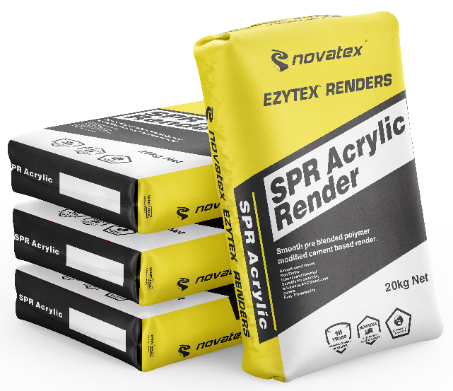

- Acrylic modified
- Easy trowelability
- creamy
- Build up to 10mm in single application.
- Smooth render finish

Superior formulation, ideal product for indoor and outdoor applications.

Suitable for traditional style rendering methods.

Ideal for bonding a large range of substrates including AAC blocks, brickwork, concrete and concrete block work.

Low VOC content- meets Green Building Council of Australia Green Star IEQ-13 requirements.

SPR ACRYLIC: SMOOTH POLYMER RENDER

Characteristics
SPR acrylic is a multipurpose, acrylic render that boasts superior trowelability and its unique formulation allows it to be applied up to 10mm with no sagging or cracking. SPR acrylic can be applied using traditional hawk and trowel methods over brick work, AAC blocks, concrete and concrete block work.

Preparation
Ensure new concrete is allowed to cure for a minimum of 5 days. Ensure all surfaces are sound, dry and free from oil, dust, grease, wax, curing compounds, release agents and any other contaminating materials. It is recommended that all dry and porous surfaces should be primed first using Nova Mix Additive with water mixed 1:1. Warning, do not over seal, only apply one coat. Where excessive suction is a problem add approximately 200ml of Nova Mix Additive per bag to first coat.

Mixing
Depending on weather conditions and application a slight variation in the amount of water may be required. The mixing ratio of SPR Acrylic is 20kg of powder to 3.0 to 3.5 Liters of water. Pour 3.0 to 3.5 Liters of clean water into a drum and then gradually add the SPR Acrylic while mixing continuously until smooth lump free mix is obtained. Always add powder to liquid. Allow the mix to stand for 5 min. Re stir and the SPR Acrylic is ready to use.

Application
Once the substrate has been correctly prepared in accordance with the above instructions. Trowel on SPR Acrylic evenly onto surface. A straight edge can be used to check level or flatness of the applied render. Allow render to stand for 10 -30 minutes, depending on ambient and surface conditions. Using a wooden float or plastic float work can begin on rendered surface. For a sandy finish use a sponge float to achieve required effect. SPR Acrylic is useable for up to 1 hour at 23^{O}C and 50% relative humidity.

Drying Time
SPR Acrylic is touch dry in 2 to 4hrs at 23°C. Second coat may be applied after 6-8hrs and surface will reach full cure after 7 days. Before application of a decorative finish (i.e. paint) allow SPR Acrylic to cure for a minimum of 1 day per 2mm thickness of the render. Cold, damp or humid conditions may lengthen the drying time.

Coverage
2-4m² per 20kg bag depending on surface and application thickness.

Cleaning
SPR Acrylic can be cleaned off equipment with water, provided the compound has not dried. Keep out of sewers and storm water. Sweep up spills.

Shelf Life
9 months when stored in a dry place, in original unopened packaging.

The information supplied is to the best of our knowledge true and accurate. The actual application of the product is beyond the manufacturer’s control. Any failure or damage caused by the incorrect usage of the product is not the responsibility of the manufacturer. The manufacturer insists that all workmanship must be carried out in accordance with the manufacturer’s specification. To the full extent permitted by law, Novatex Products Pty Ltd liability is limited to its discretion, to replacement of good or the supply of equivalent goods.

SPR ACRYLIC: SMOOTH POLYMER RENDER

Colour | Grey
Pot Life | hour
Touch Dry | to 4 hours
Recoat time | to 8 hours
Full cure | days
Precautions
SPR Acrylic is not suitable for using over floors. If applying over painted surfaces (contact your nearest Novatex office for correct application). Do not apply in temperatures below 5°C or above 35°C or application in extreme conditions such as high wind, direct sunlight, rain and water runoff.

Health and Safety
The powder can be irritable; Paper dust protection masks must be worn while product is being mixed. The wet compound is alkaline and prolonged skin contact should be avoided.

Disclaimer
Please note: Recommendations and advice regarding the use of this product are to be taken as a guide only. Novatex shall not be liable for any inaccuracy in the information given or for any loss, injury or damage whatsoever resulting from its use. To the full extent permitted by law, Novatex Products liability is limited to its discretion, to replacement of goods or the supply of equivalent goods. For applications/ situations not mentioned on this packaging, please contact your nearest Novatex office.

Technical Data

