Terranova
FAST SETTING HIGH ADHESION STRENGTH TILE ADHESIVE

TECHNICAL DATA SHEET

TERRANOVA is a premium grade fast setting, non-slip, non-slump, flexible off-white tile adhesive specially designed for moisture sensitive stone.

TERRANOVA is the ultimate when it comes to tile adhesives, with its superior adhesion strength, Rapid set time and flexibility. TERRANOVA outperforms its opposition in every aspect of application and cost.
TERRANOVA is fast setting allowing tiles to be trafficable after only 4 hrs.
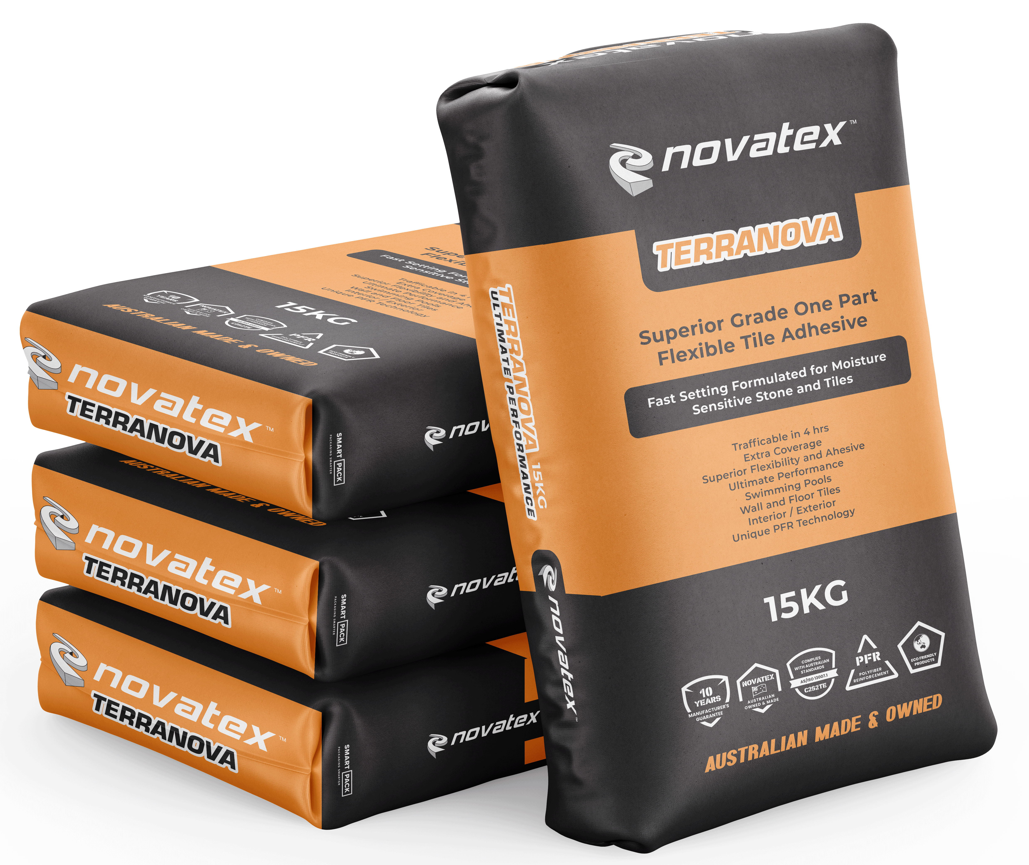
- High performance
- Flexible
- Non-Slump
- Fast set in 4 hrs o Adhesive-meets C2S2FTE classifications
- For moisture sensitive stone

Superior coverage, ideal product for commercial applications where rapid turnaround is required e.g. shopping centres, fast food stores, convenience stores and petrol stations.

Suitable for tile-on-tile wall and floor applications and internal external use.

Ideal for bonding a large range of tile types including ceramic, fully vitrified, porcelain, natural stone, terrazzo, glass, mosaics and moisture sensitive stone.

Ideal for application of tiles over Nova proof modified polyurethane waterproofing membrane.

Low VOC content- meets Green Building Council of Australia Green Star IEQ-13 requirements.

Terranova: FAST SETTING HIGH ADHESION STRENGTH TILE ADHESIVE

Designed for fixing.
Suitable for wall and floor applications internal and external use.
Ideal for bonding a large range of tile types including ceramic, fully vitrified, porcelain, natural stone, marble, terrazzo, glass, mosaics and moisture sensitive stone. Ideal for application of tiles over Nova proof modified polyurethane waterproofing membrane.

Substrates
Concrete, renders, screeds, Nova proof waterproofing membrane, block work, gyprock, plasterboard and fibre cement surfaces.

Preparation
Ensure surfaces are sound and free from movement, paint, oil, grease, wax, dust and any curing compounds and release agents and any other barrier materials. Ensure surface to be tiled over is strong enough to support the weight of the tiles being fixed. Surface needs to be dry before tiling, with no residue or permanent damp.

Concrete & Cement Render Screeds
Ensure all concrete slabs are allowed to cure for at least 7 days in accordance with AS 3958.1-2007 and have a wood float finish. The maximum variation in the plane of the concrete must not exceed 5mm in 3 meters for floors and 4mm in 2 meters for walls. Steel trowelled finished concrete surfaces must be mechanically abraded or primed first using Optimus Primer.
All render surfaces must be allowed to cure for at least 24 hrs. prior to commencing tiling.

Plaster Board /Fibre Cement Sheet Wall and Floor
Fibre cement sheeting must be the correct sheeting for the installation and be used and installed in accordance with the manufacturer’s written specifications. The surface must be primed with NovaPrime. For framed floors, modify TERRANOVA using Nova Mix Additive. Mix 2.0L of Nova Mix Additive and 2.5L of water. Then add a 16kg bag of TERRANOVA while mixing.

Plasterboard sheets must be the correct sheeting for the installation and be used and installed in accordance with the manufacturer’s written specifications. The surface must be primed with NovaPrime.

Timber
Timber floors must be sheeted with a suitable tile underlay. Install a suitable ceramic tile underlay according to the manufacturer’s printed directions then prime with Nova Prime

Existing Tiles
Tiles need to be sound and clean. Remove all cracked, drummy or otherwise unsound tiles and repair appropriately. Prime with Novatex Optimus Primer. Contact Novatex Products before commencing if in doubt about required surface preparation.

Expansion & Movement Joints
Must be installed in accordance with Australian Standard AS3958.1-2007.
Movement Joints must be placed from the substrate through the tile bed up to the face of the tile. Movement joints must be clean and free from dirt, adhesive droppings and tile spacers. They must be a minimum of 6mm wide and no wider than 10mm. They should be filled with a suitable elastomeric sealant such as Forza.

The information supplied is to the best of our knowledge true and accurate. The actual application of the product is beyond the manufacturer’s control. Any failure or damage caused by the incorrect usage of the product is not the responsibility of the manufacturer. The manufacturer insists that all workmanship must be carried out in accordance with the manufacturer’s specification. To the full extent permitted by law, Novatex Products Pty Ltd liability is limited to its discretion, to replacement of good or the supply of equivalent goods.
Terranova: FAST SETTING HIGH ADHESION STRENGTH TILE ADHESIVE
Movement joints must be placed:
On floors, every 4.5 metres externally and every 6 metres internally. Around the perimeter of the floor. Where 2 different materials meet (e.g. wood and concrete). Around fixtures in the substrate (e.g. columns).
On walls, every 3 to 4.5m. Internal vertical corners; changes in direction of the tiling at changes in story height. Over existing movement joints. As recommended by the sheet manufacturer. See special instructions for exterior framed decks.

Priming
All porous surfaces should be primed using Nova Prime (refer to Nova Prime data sheet for correct application). Non-Porous surfaces should be primed using Optimus Primer (refer to Optimus Primer data sheet for correct application)

Mixing
16kg of TERRANOVA powder requires 4-4.5 litres of water. Always add powder to liquid while stirring. Stir thoroughly until powder is fully incorporated into the water. Allow to stand for 3min and then restir. Adhesive is now ready to use.

Application
All tiling must be carried out in accordance with AS3958:2007 – A Guide to Tiling. Once the substrate has been correctly prepared then apply the adhesive onto surface. Floor tiles less than 300x300 use a 10mm square notched trowel. For over 300x300 use a 12mm trowel and for 400x400 and larger use a 12mm trowel as well as back buttering each tile. Use a 6mm notched trowel for wall tiles up to 200x200mm. TERRANOVA can be applied at a bed thickness between 2 to 10mm for walls and 3 to 10mm for floors. Tiles must be firmly pressed in the freshly trowelled adhesive, slide the tile at a right angle to the notch pattern to ensure 100% coverage is achieved. Do not spot fix. For tiles that are uneven on the back or have lugs or grooves on the back of the tile, these need to be buttered with adhesive as well.

Grouting
Commence grouting when tile adhesive has hardened sufficiently so that the tiles will not be dislodged. Nova Grout should be mixed with Nova Mix Additive in accordance with the grout Technical Data Sheet.

Clean up.
Excess adhesive can be removed using a clean damp cloth while still wet. Tools and other equipment can be cleaned up using water while the adhesive is still wet.

Coverage
A 16kg bag of TERRANOVA will cover approximately 10m² on walls using a 6mm notched trowel and 6m² on floors using a 10mm notched trowel. The coverage will vary depending on substrate condition, tile type and application technique.

Packaging
TERRANOVA is available in 16kg bags.

Shelf Life
A bag of TERRANOVA, when kept in a cool, dry environment, and stored above ground level, will have a shelf life of 12 months.

Terranova: FAST SETTING HIGH ADHESION STRENGTH TILE ADHESIVE

Colour | Off White
Mixing Ratio | Approx. 5.5l water per 20kg powder
Application Properties | At 23⁰C and 50% RH
Open Time | 20 minutes
Adjustment time | 30 minutes
Grouting time | 4 hours
Ready for use | 4-6 hours
Pot life | 46 minutes
Suitable for Under floor heating | Yes
Mechanical Properties (ISO 13007.1)
Tensile Adhesion Strength after 6 hours dry | 0.6MPa
Tensile Adhesion Strength after 28 days dry | 2MPa
Water immersion | 1.5MPa
Heat | 1.5MPa
Freeze Thaw | 1.5MPa
Specific Gravity | 1.4kg per litre
Classification | C2S2FTE
Precautions
Do not apply TERRANOVA in temperatures below 5°C and above 35°C. In cool weather, adhesive will take longer to cure. TERRANOVA has an open time of 20 minutes and an adjustment time of 30 minutes. Please be aware of site conditions and only spread enough adhesive so that tiles can be fixed while the adhesive is still wet. Do not set tiles into “skinned” adhesive. Remove any skinned adhesive and reapply fresh wet material. TERRANOVA is not suitable for use in pools or for direct stick to timber. Seek special instructions for heavy stone on walls. Not suitable for framed floors with spans longer than 5m

Ensure that exterior tiling or tiling in wet areas has suitable falls to avoid ponding. Protect tiling from water, rain and bad weather until at least 24 hours after grouting. For applications or situations not mentioned in this data sheet please contact Novatex Products Pty Ltd.

For a full MSDS for TERRANOVA please contact Novatex Products Pty Ltd.

TERRANOVA being cement based is alkaline in nature, and therefore may cause dermatitis. It is recommended that applicators wear PVC gloves or similar and safety goggles.

Technical data

Contact Us
For further technical information, please contact Novatex Products on 02 9616 6500.

The information supplied is to the best of our knowledge true and accurate. The actual application of the product is beyond the manufacturer’s control. Any failure or damage caused by the incorrect usage of the product is not the responsibility of the manufacturer. The manufacturer insists that all workmanship must be carried out in accordance with the manufacturer’s specification. To the full extent permitted by law, Novatex Products Pty Ltd liability is limited to its discretion, to replacement of good or the supply of equivalent goods.

