Tint N Prime
HIGH PERFORMANCE TINTABLE PRIMER

TECHNICAL DATA SHEET

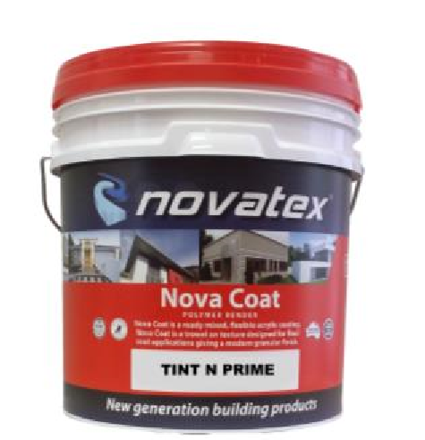
Tint N Prime is a high performance, acrylic tintable primer. It is specially designed to seal and prime all clean masonry surfaces while providing excellent adhesion. Tint N Prime is specially formulated to allow colours to be reproduced with economical tint additions.

- Excellent adhesion
- Tintable
- Superior coverage
- Good hiding power
- Easy spread ability

Superior coverage, ideal product for commercial applications e.g. shopping centres high rise.

Suitable for priming over Novatex rendering systems.

Low VOC content- meets Green Building Council of Australia Green Star IEQ-13 requirements.
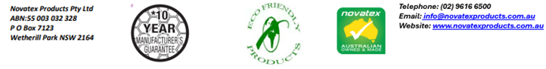

Tint N Prime: HIGH PERFORMANCE TINTABLE PRIMER

Characteristics
Tint N Prime is a high performing, acrylic tintable primer specially designed to seal and prime over rendered surfaces prior to applying Bondi Bling over a variety of surfaces such as brick work, AAC blocks, blue board (Fibre cement sheet) concrete, polystyrene surfaces and specified light weight building substrates when properly prepared.

Preparation
All surfaces must be clean and free from dirt, dust, oil, grease, wax, curing compounds, release agents and other contaminated materials. Glossy surfaces should be lightly sanded and cleaned before priming. Fill cracks and any small imperfections using Flex N Patch. Where mortar joints and other imperfections need to be concealed apply Ezy Tex Renders according to specifications and leave as a float finish. Tint N Prime can be applied over any Novatex cement-based renders after 48 hrs, new concrete surfaces should be left to cure for a minimum of 28 days and cement renders left to cure for a minimum of 7 days.

Mixing
Tint N Prime is a premixed product that is supplied white in colour and can be tinted to most modern colours.

Application
Once substrate has been appropriately prepared in accordance with the above instructions using a brush or roller, apply one coat of Tint N Prime onto surface. Tint N Prime can be tinted to the same colour of the texture being used. Once Tint N Prime has been applied allow to cure for 24 hrs prior to applying texture. For applications not mentioned contact Novates for information.

Drying Time
Dries in approximately 24 hours under normal drying conditions. (dry times may vary with changes in temperature, humidity and residual moisture in the substrate).

Coverage
A 15ltr pail of Tint N Prime will cover approximately 90 m².

Cleaning
Keep out of sewers and storm water. Sweep up spills. Novatex Tint N Prime can be cleaned off equipment with water, provided the compound has not dried.

Shelf Life
12 months when stored in a dry place, in original unopened packaging.

Precautions
Do not apply in temperatures below 5°c or above 35 °c or application in extreme conditions such as high wind, direct sunlight, rain and water runoff.

The information supplied is to the best of our knowledge true and accurate. The actual application of the product is beyond the manufacturer’s control. Any failure or damage caused by the incorrect usage of the product is not the responsibility of the manufacturer. The manufacturer insists that all workmanship must be carried out in accordance with the manufacturer’s specification. To the full extent permitted by law, Novatex Products Pty Ltd liability is limited to its discretion, to replacement of good or the supply of equivalent goods.
Tint N Prime: HIGH PERFORMANCE TINTABLE PRIMER

Health and Safety
Tint N Prime is non hazards. In case of eye contamination, rinse thoroughly with clean water and seek medical advice. Wear protective clothing to minimize skin contact and safety glasses where spatter is likely.

Disclaimer
Please Note: Recommendations and advice regarding the use of this product are to be taken as a guide only. Novatex Products shall not be liable for any inaccuracy in the information given or for any loss, injury or damage whatsoever resulting from its use. To the full extent permitted by law, Novatex Products liability is limited to its discretion, to replacement of goods or the supply of equivalent goods. For applications/situations not mentioned on this packaging, please contact your nearest Novatex office.

Contact Us
For further technical information, please contact Novatex Products on 02 9616 6500.

