Valencia
Enhanced Pre-Mixed Modified Acrylic

TECHNICAL DATA SHEET

Valencia is a ready mixed, flexible, texture acrylic coating ideal for covering and decorating suitably prepared interior or exterior surfaces.

Valencia is an attractive granular texture finish ideally suitable to modern construction while maintaining a traditional look.

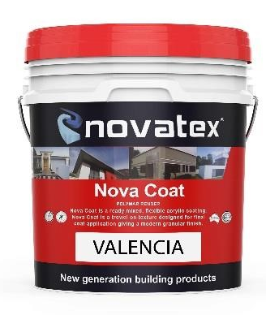
Valencia is a pre blended, acrylic texture and its unique formulations allows easy trowelability. Valencia is specially designed with the unique BIS formulating system giving it superior mould and dirt resistance.

- Acrylic modified
- Built in sealer.
- Tintable
- Easy trowelability
- Superior adhesion and flexibility
- Modern granule texture finish

Superior formulation, ideal product for commercial applications e.g. shopping centres, high rise buildings and housing developments.

Designed as a texture coat over render it is also ideal for bonding to a large range of substrates including AAC blocks, AFS, brick work, fibre cement sheeting, concrete and polystyrene board, Dincel wall.

Low VOC content- meets Green Building Council of Australia Green Star IEQ-13 requirements.

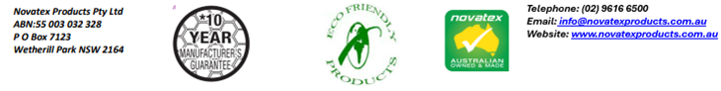
Valencia: Enhanced Pre-Mixed Modified Acrylic

Designed for
Use over Novatex Render. Also suitable for internal and external applications. Can be used over brick work, AAC blocks, blue board (fibre cement sheet) concrete, Dincel wall and polystyrene board (contact your nearest Novatex office for correct application).

Preparation
Ensure new concrete is allowed to cure for a minimum of 28 days and cement render after 7 days. Valencia can be applied over Novatex Ezy Tex cement-based renders after 48hrs. Ensure all surfaces are sound, dry and free from oil, dust, grease, wax, curing compounds, release agents and any other contaminating materials. It is recommended that surfaces should be primed first using Nova Coat Primer (tintable) when not over coating Valencia. Note: Valencia can be tinted.

Application
Once the substrate has been correctly prepared in accordance with the above instructions. Stir Valencia thoroughly first. Apply a tight coat of Valencia using a steel trowel and float off using a plastic float. A wet edge should be maintained throughout the application and day joints formed at corners, expansion joints or mouldings where they will not be evident in the finish. When tinting Valencia, it must be boxed during application to achieve a consistent colour on the wall and to eliminate shade variation between individual pails. It is recommended that the final coat is painted with an acrylic sealer or one coat of Novatex Solartite membrane paint. Allow at least 5 days for curing (depending on weather conditions) before painting. Finished work must be protected from rain fall until cured.

Drying Time
Valencia is touch dry in 6 to 8hrs at 23°C and surface will reach full cure after 7 days. Before application of paint or sealers allow Valencia to cure for a minimum of 1 day per 2mm thickness of the render. Cold, damp or humid conditions may lengthen the drying time.

Coverage
12m² per 15ltr pail depending on surface and application.

Packaging
Valencia is available in a 15 Litre pail.

Cleaning
Keep out of sewers and storm water. Scoop up spills. Novatex texture can be cleaned off equipment with water, before the compound has dried.

Shelf Life
12 months when stored in a dry place, in original unopened pail.

The information supplied is to the best of our knowledge true and accurate. The actual application of the product is beyond the manufacturer’s control. Any failure or damage caused by the incorrect usage of the product is not the responsibility of the manufacturer. The manufacturer insists that all workmanship must be carried out in accordance with the manufacturer’s specification. To the full extent permitted by law, Novatex Products Pty Ltd liability is limited to its discretion, to replacement of good or the supply of equivalent goods.

Valencia: Enhanced Pre-Mixed Modified Acrylic

Colour | White Base
Mixing Ratio | Pre-Mixed
Application Properties at 23°C and 50% RH
Paint over | 48 hours
Dry Time | 24 hours
Open Time | Approx.30 Minutes
Precautions
Valencia is not suitable for using on floors. If applying over painted surfaces prime area using Optimus Primer (contact your nearest Novatex Office for correct applications) Do not apply in temperatures below 5°C or above 35°C or application in extreme conditions such as high wind, direct sunlight, rain and water runoff, or when rain is imminent.

Health and Safety
Valencia is a non-hazardous product. Ensure adequate ventilation when using. If product splashes into eyes rinse thoroughly for at least 15 minutes with clean water. If Valencia comes in contact with the skin, wash well to remove.

Disclaimer
Please Note: Recommendations and advice regarding the use of this product are to be taken as a guide only. Novatex Products shall not be liable for any inaccuracy in the information given or for any loss, injury or damage whatsoever resulting from its use. To the full extent permitted by law, Novatex Products liability is limited to its discretion, to replacement of goods or the supply of equivalent goods. For applications/situations not mentioned on this packaging, please contact your nearest Novatex office.

Technical Data

Contact Us
For further technical information, please contact Novatex Products on 02 9616 6500.

