Base & Patch
Enhanced Pre-Blended Modified Cement Based Render

TECHNICAL DATA SHEET
Ezytex Base and Patch is a multipurpose, high polymer modified render that especially suitable for difficult substrates.

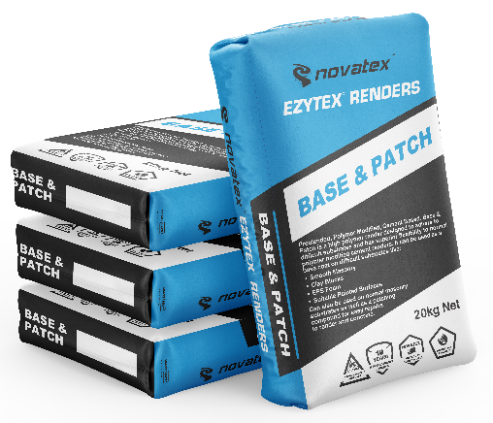
Ezytex Base and Patch has superior flexibility and tensile strength to normal cement renders. It can be used as a base render for difficult substrates like smooth masonry, clay bocks, tilt up panels, polystyrene foam and suitable painted surfaces. Can also be used as a patching compound for render and concrete.

- Highly polymer modified.
- Suitable for difficult substrates.
- Easy trowelability.
- Suitable for non-shrink patching.
- Unique PFR Technology

Superior formulation, ideal product for commercial applications e.g. shopping centres, high rise, and housing developments.

Suitable for traditional style rendering methods.

Can also be used on common masonry substrates like off form concrete, brickwork and blockwork for both rendering and patching.

Low VOC content- meets Green Building Council of Australia Green Star IEQ-13 requirements.

Base & Patch: Enhanced Pre-blended Modified Cement Based Render
Characteristics
Preblended, Polymer Modified, Cement Based. Base and Patch is a high polymer render designed to adhere to difficult substrates and has superior flexibility to normal polymer modified cement renders. It can be used as a base coat on difficult substrates like: Smooth Masonry, Clay Blocks, Polystyrene Foam. Can also be used on normal masonry substrates as well as a patching compound for easy repairs to render and concrete.

Preparation
Concrete should be cured for 28 days. Block and brick walls should be fully cured before rendering. Polystyrene foam panels must be installed in accordance with the manufacturer’s instructions. All surfaces must be clean and free from dirt, old flaky paint, dust, oil, grease, silicone or loose materials before application. It is recommended that all dry and porous surfaces be primed first using Nova Mix additive with water mixed 1:1. Warning do not over seal, usually only one coat is required, but AAC block may require 2 coats. Tilt up and cast in place panels should be ground back prior to priming with Nova Mix additive with water mixed 1:1. For painted surfaces, ensure that the paint is sound and is alkali resistant. Oil based paint is generally not alkali resistant. If there is any doubt about the type of paint or the adhesion of the paint, or if the painted area is larger than 20m², remove all paint.

Mixing
Always add powder to liquid. For masonry and blockwork, pour 5 litres of water into a clean bucket and slowly add Base and Patch powder while stirring. Add entire contents of bag and adjust with water (approx. 0.5 litres) to achieve the desired consistency. Allow to stand for 2 minutes and restir before application.

Application
Base and Patch application should only be carried out by a skilled and experienced applicator. Base and Patch should be applied in a single coat between 2mm and 4mm. Base and Patch can be sprayed on with a suitable machine or applied manually using traditional hawk and trowel methods. Allow Base and Patch to firm up sufficiently prior to ruling off to form a flat surface. Lightly float to achieve a smooth surface. Render should be sheltered from rain & moisture for 24hrs after completion dependent on climatic conditions. For higher build thickness, an extra coat of Base and Patch may be applied after 4-8 hours. Once Base and Patch is fully cured, a Novatex finishing render or texture coat should be applied followed by 2 coats of Nova Coat Membrane. Base and Patch should not be left uncoated for an extended period.
When used as a patching compound mix and apply as above. Do not exceed 5mm thickness in one coat. When rendering EPS Foam, apply Base and patch directly to the clean foam and bed alkali resistant glass mesh into the render and then apply.

Drying Time
Dries in approximately 24 hours under normal drying conditions. (Dry times may vary with changes in temperature, humidity and residual moisture in the substrate). Once initial dry set has occurred, rewet I to 2 times a day with clean water for 2 days. This is especially important during hot and/or windy weather. Under normal conditions Base and Patch is fully cured in 7 days. Before application of a decorative finish, allow Base and Patch to cure for a minimum of 1 day per 2mm thickness of the render. Cold, damp or humid conditions may lengthen the drying time.

The information supplied is to the best of our knowledge true and accurate. The actual application of the product is beyond the manufacturer’s control. Any failure or damage caused by the incorrect usage of the product is not the responsibility of the manufacturer. The manufacturer insists that all workmanship must be carried out in accordance with the manufacturer’s specification. To the full extent permitted by law, Novatex Products Pty Ltd liability is limited to its discretion, to replacement of good or the supply of equivalent goods.

Base & Patch: Enhanced Pre-blended Modified Cement Based Render

Tiling
Masonry and blockwork, rendered with Base and Patch can be tiled over with Novatex Uninova or Novamastic Tile Adhesive. Hollow block must be core filled and reinforced with steel. Do not tile over exterior rendered EPS foam. Do not tile over rendered paint. Do not tile using heavy stone or moisture sensitive stone. Maximum tile weight should not exceed 32kg/m². Consult the tile adhesive data sheet prior to tiling. For swimming pools, use the recommended Novatex Render and Tile adhesive. Do not use Base and Patch

Coverage
Approximately 5m² per 20kg bag depending on surface for a 4mm build.

Cleaning
Mask any glass or building elements to minimise damage or staining. Wet render or tools and other equipment can be cleaned up using water while the render is still wet. Keep out of sewers and storm water. Sweep up spills. Novatex render can be cleaned off equipment with water, provided the compound has not dried.

Shelf Life
12 months when stored in a dry place, in original unopened packaging.

Precautions
Base and Patch is not suitable for using over floors. If applying over painted surfaces prime area using Optimus Primer (contact your nearest Novatex Office for correct applications) Do not apply in temperatures below 5°C or above 35 °C or in extreme conditions such as high wind, direct sunlight, rain and water runoff. Do not apply if overnight temperatures will fall below 5⁰C. Do not render over substrates that have been exposed to heavy prolonged rain. Do not render over expansion joints or damp courses. Do not render below ground level or constantly damp surfaces. Expansion joints must be brought through the render. Use glass mesh bedded into the render over cracks, joints, around windows and door frames. For applications or situations not mentioned in this data sheet please contact Novatex Products Pty Ltd. Data Sheets are available at www.novatexproducts.com.au.

Health and Safety
The powder can be irritable; dust protection masks must be worn while product is being mixed. The wet compound is alkaline and prolonged skin contact should be avoided.

Disclaimer, please note: Recommendations and advice regarding the use of this product are to be taken as a guide only. Novatex Products shall not be liable for any inaccuracy in the information given or for any loss, injury or damage whatsoever resulting from its use. To the full extent permitted by law, Novatex Products liability is limited to its discretion, to replacement of goods or the supply of equivalent goods. For applications/situations not mentioned on this packaging, please contact your nearest Novatex office.
For further technical information, please contact Novatex Products on (02) 9616 6500.

