Structagrout
General Purpose Cementitious Grout

TECHNICAL DATA SHEET

STRUCTAGROUT is an internal and external engineered (class A) cementitious grout that is ideal for patching all types of cement and concrete building elements including Precast and tilt up panelling.

STRUCTAGROUT gas expansion system ensures total void filling with no shrinkage cracks.

STRUCTAGROUT is ready to use. Just Mix and add water.
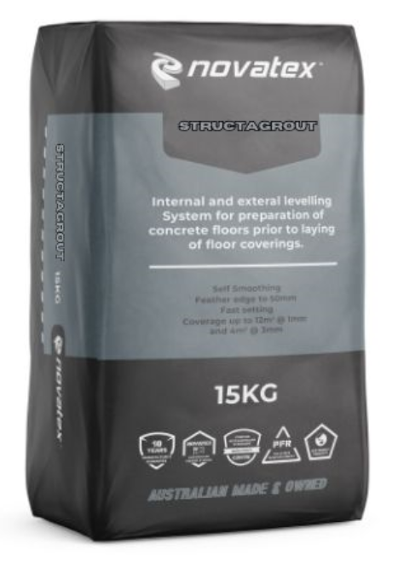
- High performance
- Internal and External Use
- Shrinkage Compensated
- Tilt up and Precast Panels
- Column Underpinning
- Suitable for Filling Hollow Block
- Can be mixed for Stiff, Plastic, Fluid and flowable Situations.
- Superior Adhesion to Concrete Surfaces
- Pumpable

Suitable for commercial installations requiring minimum downtime and rapid turnaround.

Low VOC content- meets Green Building Council of Australia Green Star IEQ-13 requirements.

Structagrout: General Purpose Cementitious Grout
Characteristics
STRUCTAGROUT is an internal and external engineered repair grout and patching compound, specifically formulated for repairs to concrete and masonry walls and floors. STRUCTAGROUT can also be used for column underpinning. STRUCTAGROUT contains an expansion agent to ensure it fills voids and obtains maximum close contact with the substrate.

Preparation
Ensure all concrete slabs are allowed to cure for at least 28 days and must be free of oil, paint, grease, wax, curing compounds, dust, old adhesive and any other contaminations, which may inhibit bond. Diamond grinding shot blasting or scarifying may be required for large areas to remove any contamination. Concrete and masonry need to be pre-soaked with water to ensure good adhesion and proper curing. Remove all residual water immediately before grouting. Substrates must not be subject to rising damp. Concrete and masonry subject to rising damp must be treated with Novatex Hydro prime prior to application. Where temperatures are less than 10⁰C or greater than 30⁰C, contact your nearest Novatex office of any additional advice.

Mixing
The mixing ratio of STRUCTAGROUT will depend on the consistency of product required.
Consistency | Water Addition per Bag (Approx.)
Stiff | 3.0 Litres
Plastic | 3.5 Litres
Flowable | 3.8 Litres
Fluid (Pumpable) | 4.2 Litres
Core Filling | 3,8 litres + 20kg 8mm Gravel

Premeasure the correct amount of water then slowly add STRUCTAGROUT while mixing. Use a heavy-duty mixer and always add powder to liquid. Mix until homogeneous and allow to stand for 5 minutes. Then mix again for a few minutes. Try to place the grout within 15 minutes of mixing to maximise post placement expansion.

Note- Do not over water as this will promote bleed and separation with a reduction in bond, tensile and compressive strength.

Application
Apply STRUCTAGROUT by trowel, pouring or pumping depending on the type of repair or volume to be used. If attempting multiple pours or applications, sequence the application to maintain a wet edge at each application. If using formwork, ensure there are bleed holes to relieve pressure of expansion. If filling large deep holes, the surface of the grout may bulge after a few hours. If a flat surface is required, trim the surface back after about 2 hours while the grout is still “green”. Otherwise allow the surface to cure and then grind back flat.

STRUCTAGROUT application thickness should be between 20mm and 120mm. Do not use STRUCTAGROUT as a fine skim or a thin screed or render.

The information supplied is to the best of our knowledge true and accurate. The actual application of the product is beyond the manufacturer’s control. Any failure or damage caused by the incorrect usage of the product is not the responsibility of the manufacturer. The manufacturer insists that all workmanship must be carried out in accordance with the manufacturer’s specification. To the full extent permitted by law, Novatex Products Pty Ltd liability is limited to its discretion, to replacement of good or the supply of equivalent goods.
Structagrout: General Purpose Cementitious Grout
General Purpose Cementitious Grout
Depending on consistency and thickness, the rate of initial set and final set will vary. Approximate setting times at20ºC at 50mm thickness are indicated in the table below:

Consistency | Initial Set | Final Set
Stiff | 2.5 hours | 3.5 hours
Plastic | 4 hours | 5 hours
Flowable | 4.5 hours | 7 hours
Fluid | 5 hours | 8 hours

Curing
STRUCTAGROUT must be wet cured to ensure maximum strength and to avoid shrinkage and surface cracking. If using formwork, use waterproof formwork and leave in place for at least 48 hours. After stripping formwork, cure for a further 5 days using plastic sheet or wet hessian. If there is no formwork, apply curing method as soon as possible after initial set.

Coverage
A 20kg bag will deliver between 3 and 4.5 litres of volume depending on the mix consistency.

Packaging
STRUCTAGROUT is available in 20 Kg paper bags

Shelf Life
A bag of STRUCTAGROUT, when stored in a cool, dry environment and stored above ground level will have a shelf life of 12 months.

Clean up .
Clean all equipment with water immediately after use, and before STRUCTAGROUT sets.

Precautions
STRUCTAGROUT is not suitable for use over painted surfaces. Do not apply in temperatures below 5°C or above 35 °C or in extreme conditions such as high wind, direct sunlight, rain and water runoff. Do not apply if overnight temperatures will fall below 5⁰C. Do not apply over substrates that have been exposed to heavy prolonged rain. Do not place over expansion joints or damp courses. Do not apply below ground level or constantly damp surfaces. Protect from rain for at least 7 days after placement. If used as an underpinning grout on heavy machinery, do not run machine for at least 7 days after installation. For applications or situations not mentioned in this data sheet please contact Novatex Products Pty Ltd. Data Sheets and Safety Data Sheets are available at www.novatexproducts.com.au.
Hazardous, contains cement silica. Wear gloves and mask when handling. Wash hands thoroughly after use. Material safety data sheets are available upon request.

Manual Handling
Manual handling of this bag without due care and attention may result in personal injury.

Structagrout: General Purpose Cementitious Grout
Technical Data
Flow / work time | 20 - 60 minutes @ 20⁰C
Initial Set Times (stiff) | 2-3 hours @ 20⁰C
Ready for floor coverings | 24 hrs @ 20⁰C
Compressive Strength (Plastic) | 1 day- 32 MPa  7 days - 40 MPa  28 days - 48 MPa
Thickness | 20mm – 120mm.

Contact Us
For further technical information, please contact Novatex Products on 02 9757 3525.

The information supplied is to the best of our knowledge true and accurate. The actual application of the product is beyond the manufacturer’s control. Any failure or damage caused by the incorrect usage of the product is not the responsibility of the manufacturer. The manufacturer insists that all workmanship must be carried out in accordance with the manufacturer’s specification. To the full extent permitted by law, Novatex Products Pty Ltd liability is limited to its discretion, to replacement of good or the supply of equivalent goods.

